***DMPM Assignment 2 part 2***

Name: Rushikesh Jyoti

Division: A

Roll no: 27

SRN: 201901139

***Question****: Lab Assign-02- Linear Regression Model for Toyota Used-Car Price*

***Code***

library(Metrics)

library(caret)

library(dplyr)

library(scales)

# 1. Read the dataset

cars<-read.csv("ToyotaCorolla.csv")

# 2. Create a model

model<-lm(Price ~ Age + KM + FuelType + HP + MetColor + Automatic + CC + Doors + Weight,

data = cars)

print(model)

print(summary(model))

# 3. Filter out the parameters with less significance

model<-lm(Price ~ Age + KM + FuelType + HP + CC + Weight, data = cars)

print(model)

print(summary(model))

pred1<-predict(model)

resd1<-residuals(model)

predict(model, data.frame(Age=5, KM=2000, FuelType="Diesel", HP=90, CC=2000, Weight=1200))

# 4. Scatter and Residual Plots

par(mfrow = c(2,1))

plot(cars$Age,resd1,main = "Residual Plot(Age and Price)",abline(0,0,col = "red"),ylab =

"Residuals",xlab = "Price in $")

plot(cars$KM,resd1,main = "Residual Plot(KM and Price)",abline(0,0,col = "red"),ylab =

"Residuals",xlab = "Price in $")

plot(cars$HP,resd1,main = "Residual Plot(HP and Price)",abline(0,0,col = "red"),ylab =

"Residuals",xlab = "Price in $")

plot(cars$CC,resd1,main = "Residual Plot(CC and Price)",abline(0,0,col = "red"),ylab =

"Residuals",xlab = "Price in $")

# 5. Metrics and Evaluation

x<-cbind(cars$Price,pred1)

x<-data.matrix(x)

x<-rescale(x)

x<-as.data.frame(x)

mae<-MAE(x$V1,x$pred1)

mse<-mse(x$V1,x$pred1)

rmse<-RMSE(x$V1,x$pred1)

r2<-R2(x$V1,x$pred1)

cat("\nMean Absolute Error:",mae,"\n\nMean Squared Error:",mse)

cat("\n\nRoot Mean Squared Error:",rmse,"\n\nR-squared:",r2,"\n\n")

# 6. Predictions

x=1:length(pred1)

plot(x, cars$Price,

pch=19, col = "yellow",main = "Model Evaluation",

xlab = "Count", ylab = "Price")

lines(x, pred1,col="red")

legend("topright", legend = c("y-original", "y-predicted"),

col = c("yellow", "red"),

pch = c(19,NA), lty = c(NA,1))

***Output***

Creating the model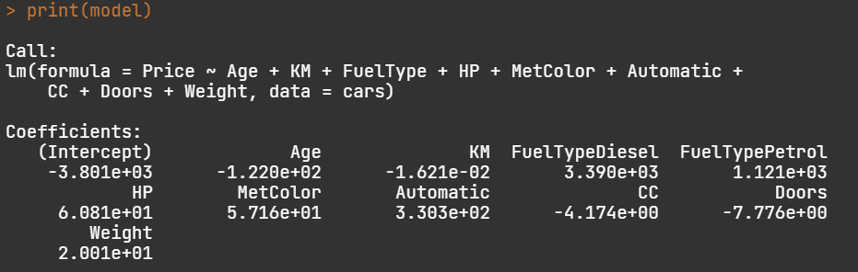Summary of model

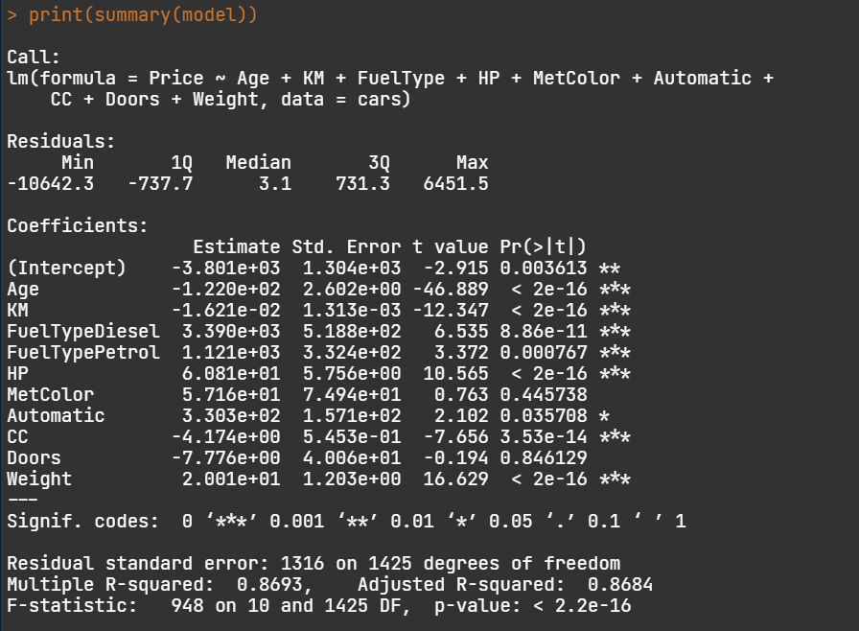

Plotting the residual values

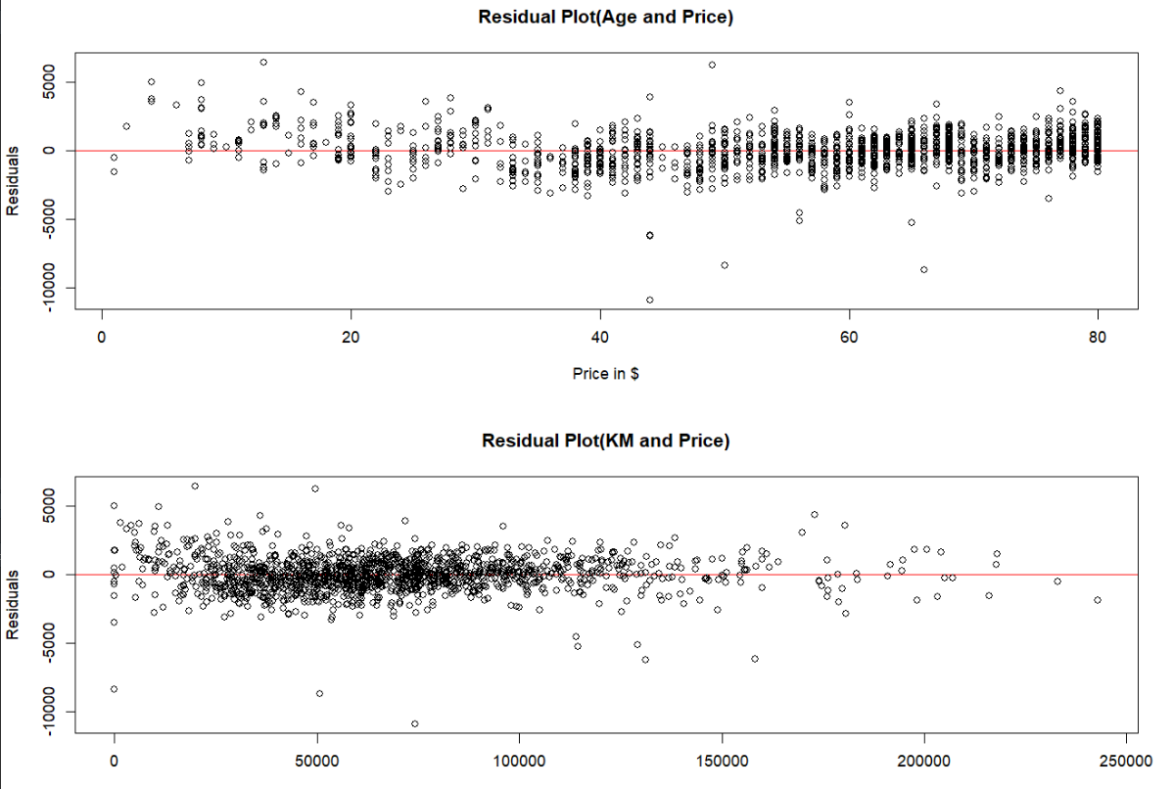

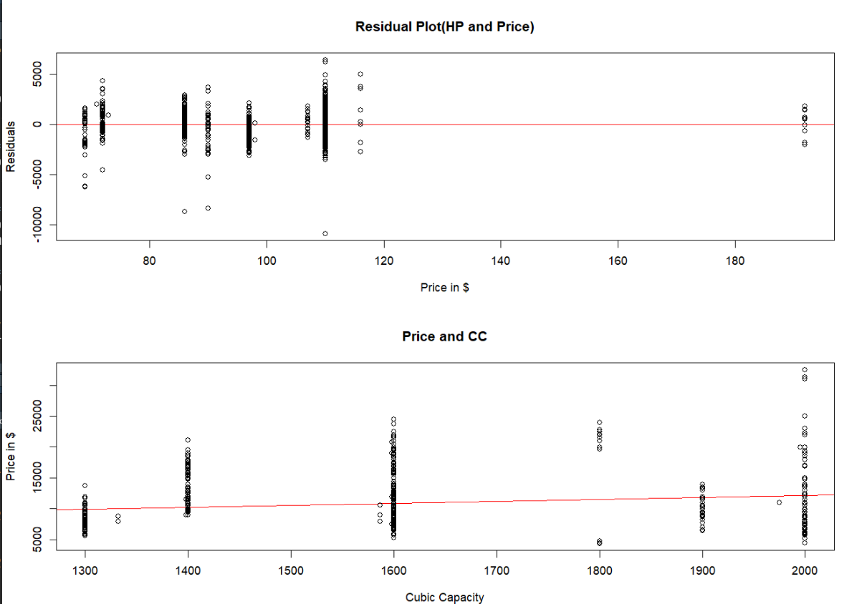

Metrics

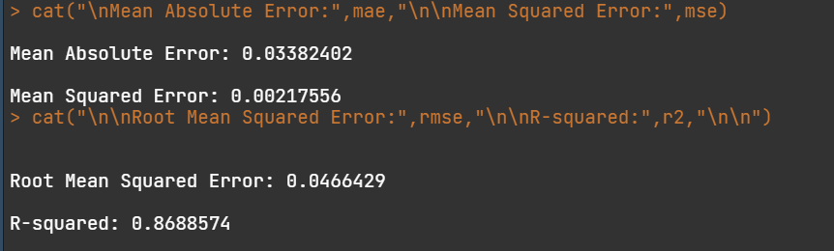

The observed errors are very small, so the accuracy of our model is good

Prediction



Prediction of a 5 year old car is 20 thousand bucks